Azure lab 2: Implement task processing logic by using Azure Functions

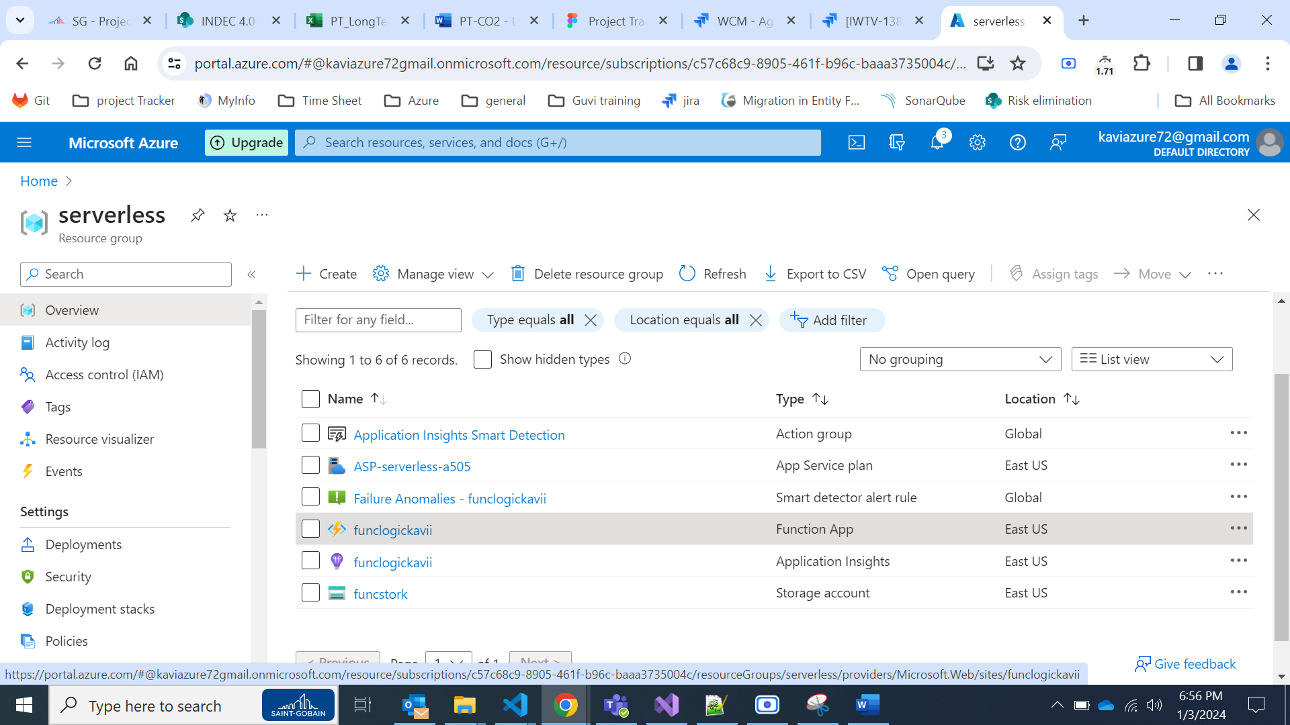

### **Exercise 3: Create a function that’s triggered by an HTTP request**

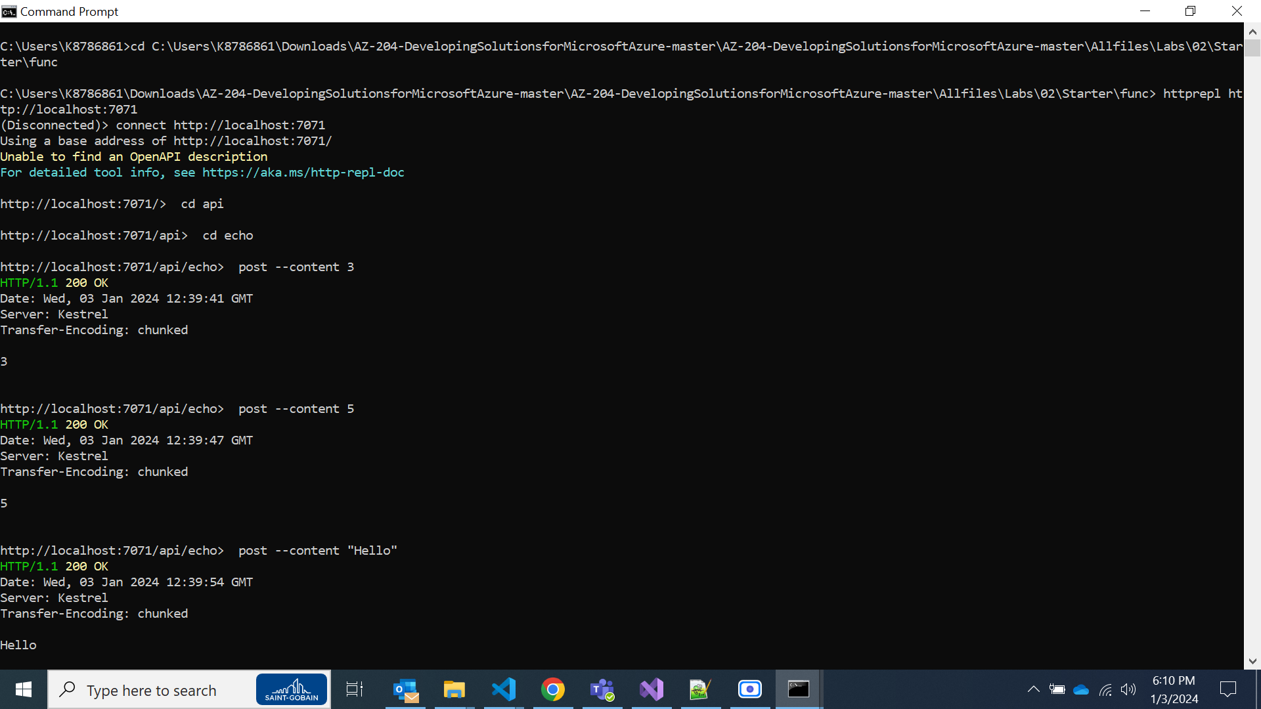

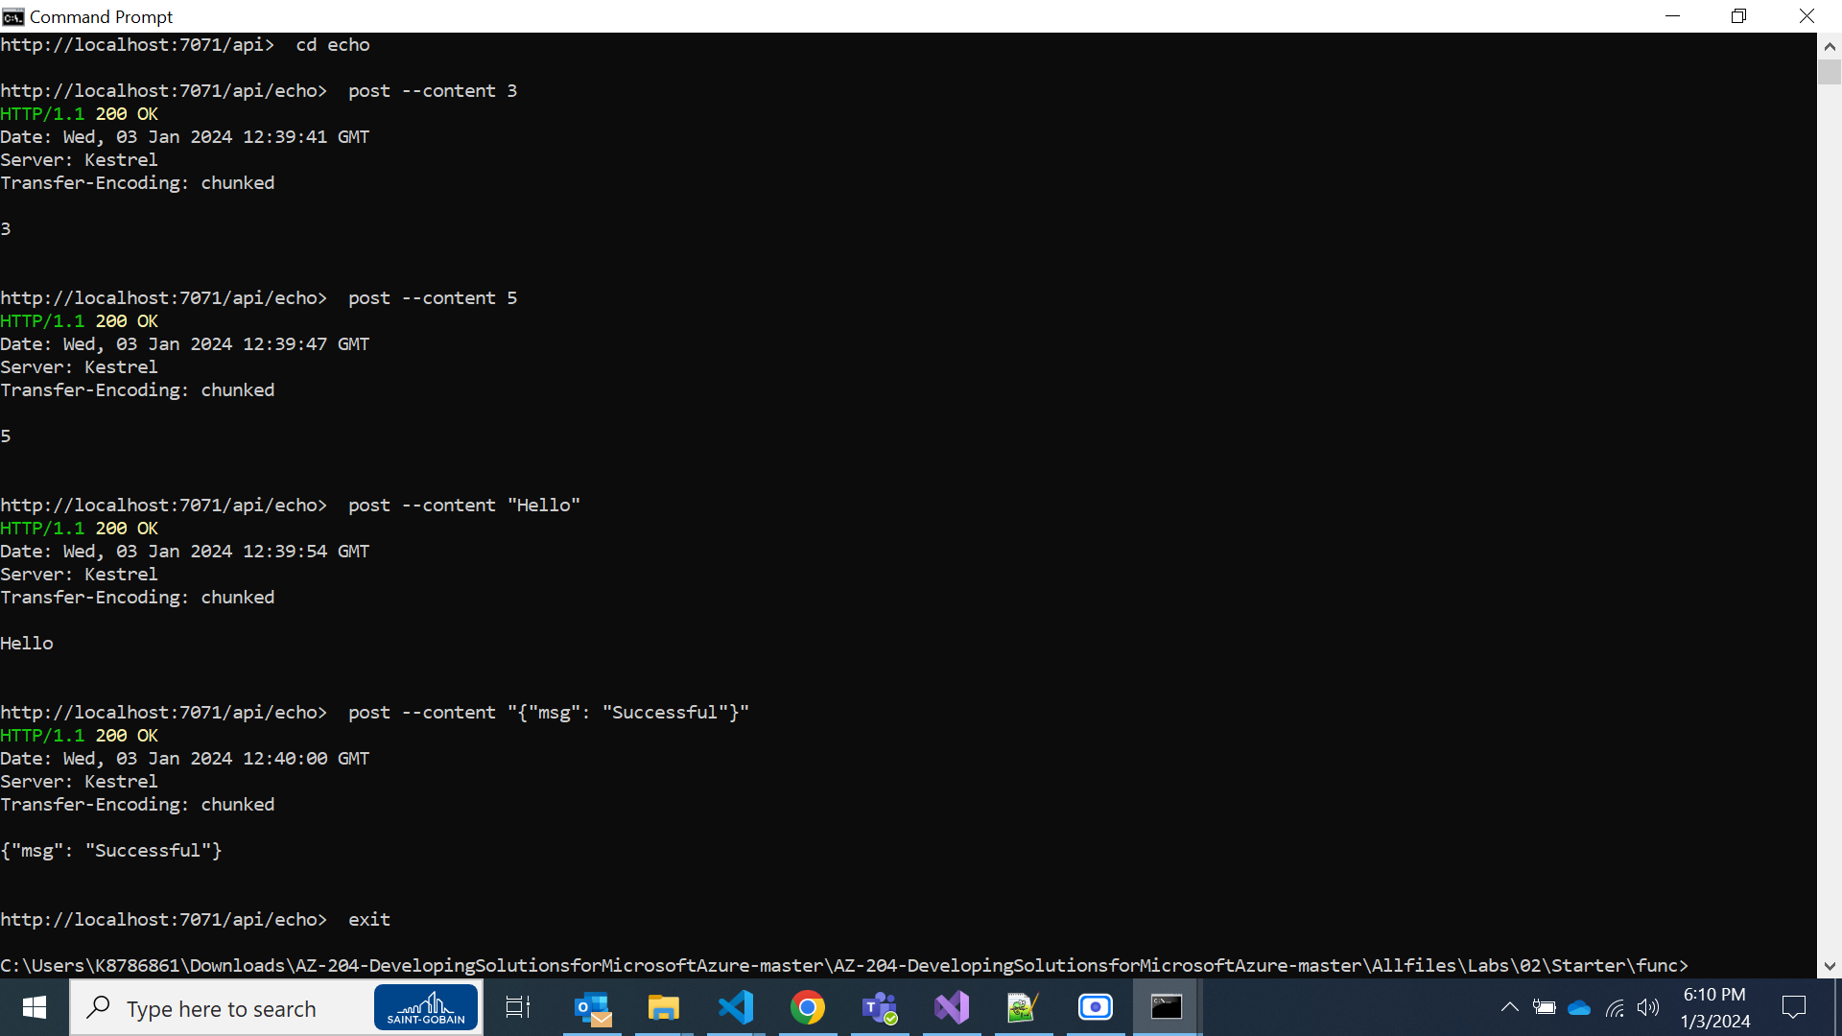

### **Exercise 4: Create a function that triggers on a schedule**

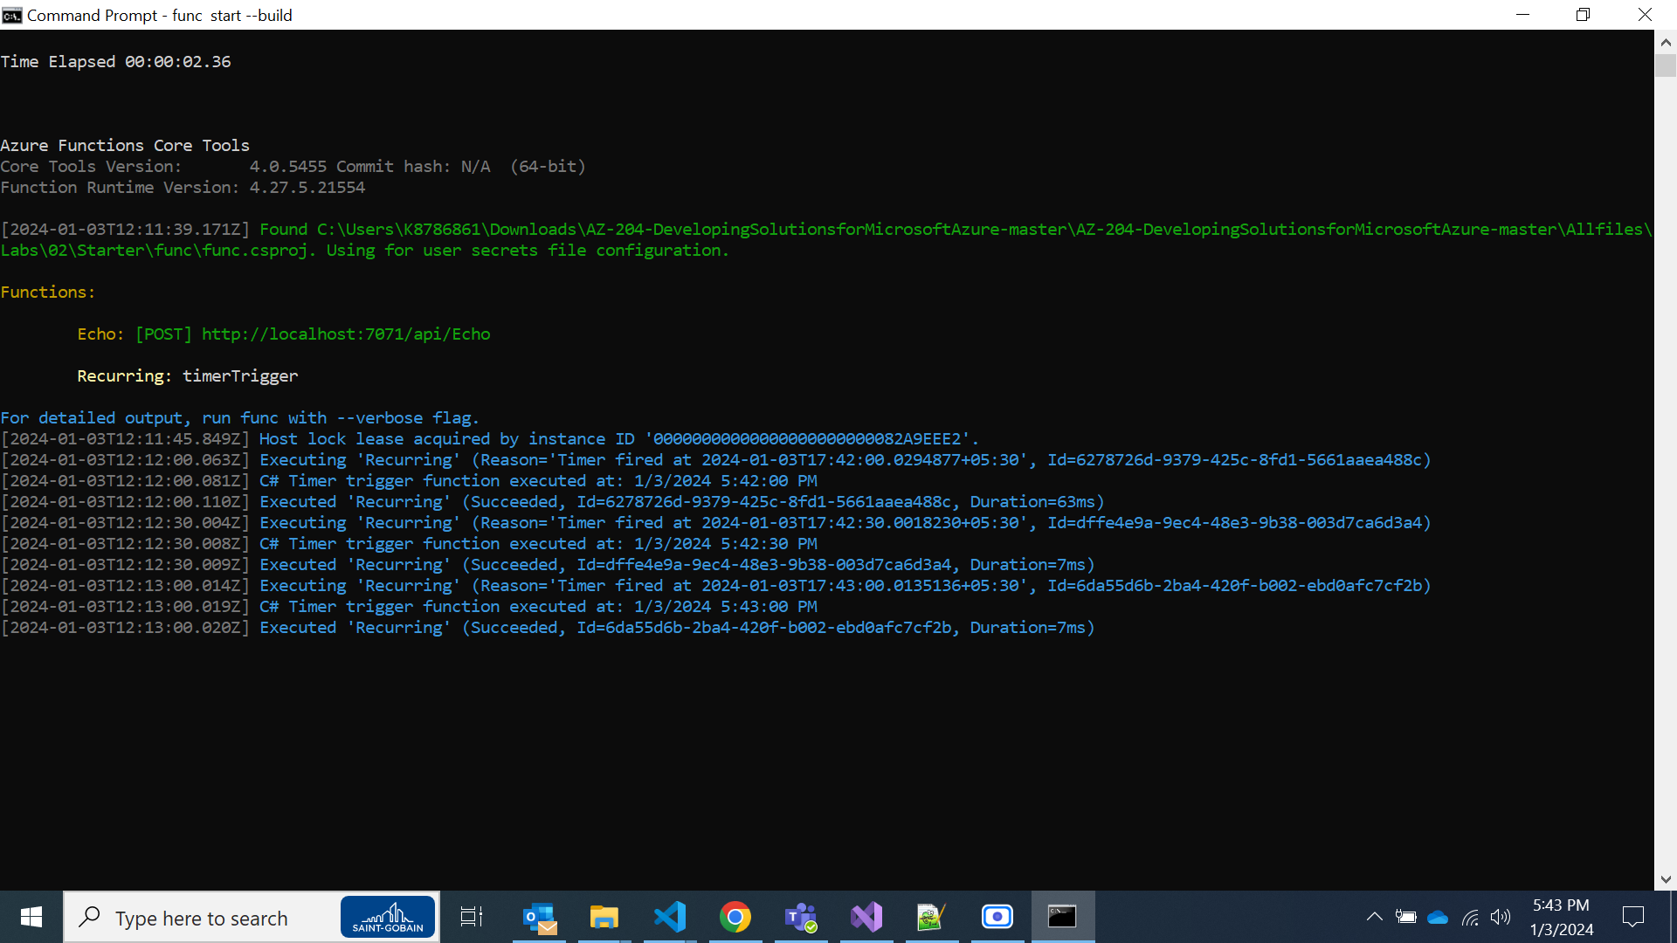

### **Exercise 5: Create a function that integrates with other services**

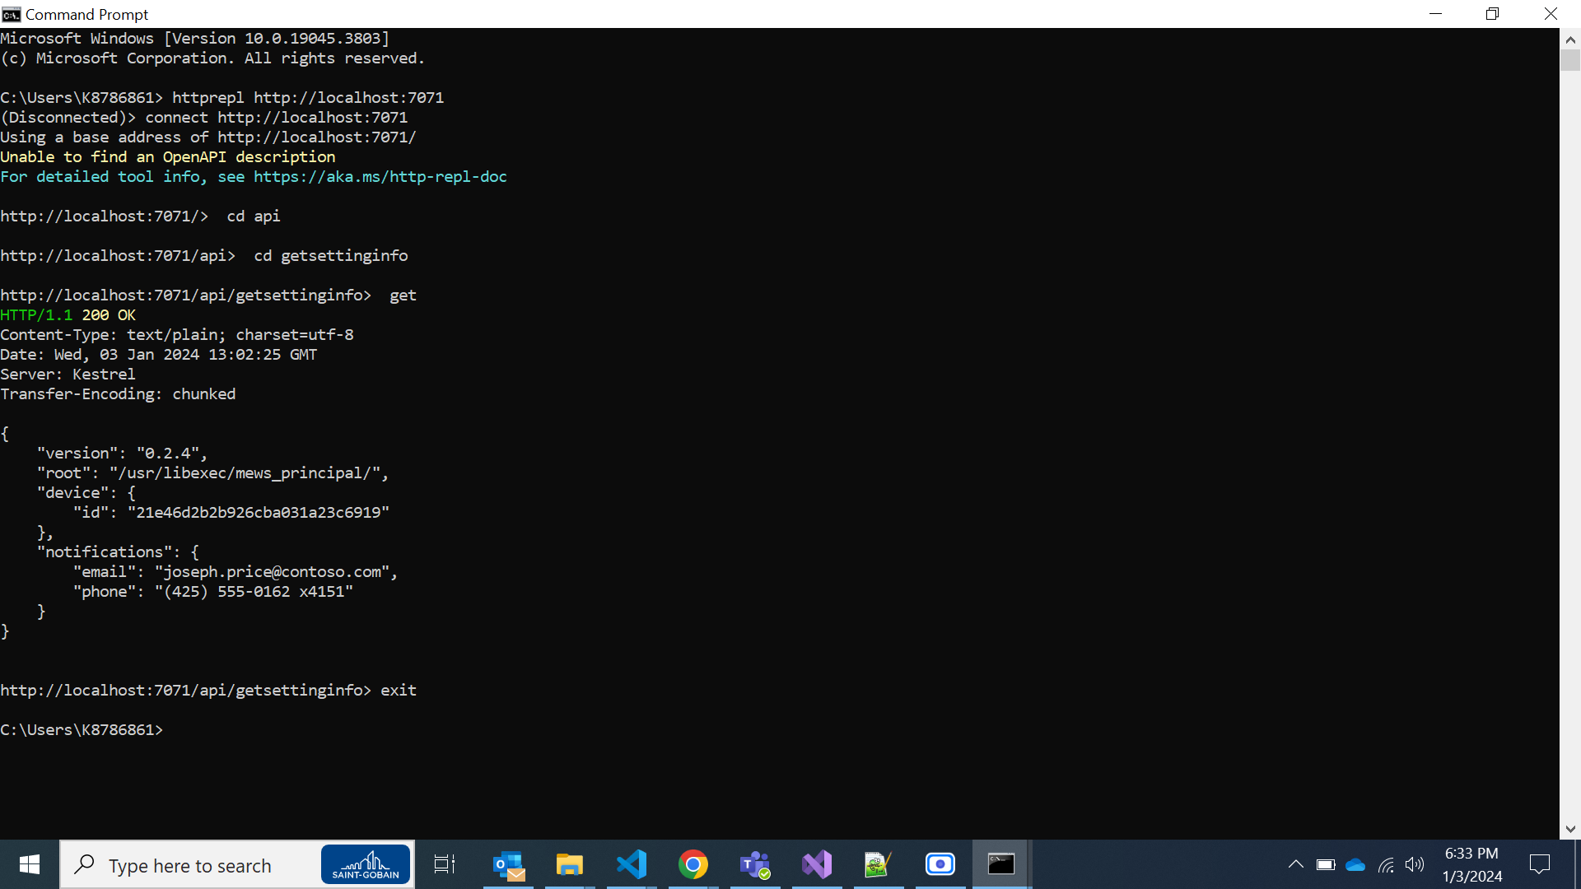

### **Exercise 6: Deploy a local function project to an Azure Functions app**

